Bellbrook Music Boosters
13Sept2021
6:00 pm
BHS Cafeteria
Executive Board Meeting Minutes

Call to Order: 6:00 pm
Roll Call: Melanie Glover, Heather Newell, Kevin Hobbs, Larissa Scott, Phoebe Dickman, Andy Soloman, Rod Silva, Rachele Alban, Jon Selvaraj, Karen Beildelchies, Vice Principal Todd Whalen
- Absent: Danielle Woeste, Jen Volmer, Rod Silva, Barb Siler
- Special Guest: Student Teacher Daniel Waugh, Kristin Selveraj
Welcome:
Approval of the Executive Meeting Minutes, 02Aug2021:

Phoebe Dickman, 1st motion, Karen Beidelschies, 2nd, All Approved

Old Business:
- Lego Raffle Fundraiser
  - The fundraiser was a great success, with $1,000 earned for the Bellbrook Music Boosters.
  - Future raffles are planned for: The Bellbrook Invitational, Christmastime, and Springtime.

- Tag Day #1
  - Director Andy Soloman reported that the first Tag Day of 2021 earned the Bellbrook Music Program over $6,800, $600 of which was in coins.
  - Mr. Soloman offered a huge thank you to all of the parents who volunteered to be drivers for the event.

- BJ’s Brewhouse Dine Out
  - Several Trustees reported issues with the Dine Out we held this past month:
    - You weren’t able to input our Fundraising Code when placing an online order.
    - Also, the amount of money that we earned does not compute to 20% of sales based on what earnings should have been from just orders placed by the Executive Board.
    - We will not be partnering with this restaurant again in the future.
New Business

- Treasurer’s Report-Appendix A

- Board of Trustees’ Report
  - Fundraising Trustee Rod Silva is absent tonight. However, he informed Trustee Chair Larissa Scott that he is still working on obtaining sponsors for the Bellbrook Invitational. He asks for anyone to contact him if they might have additional leads for sponsors.

- Officer’s Report
  - President Melanie Glover has nothing to report at this time.

- Director’s Report
  - Primary report held for the General Membership Meeting.
  - Director Andy Soloman reports that no additional bands have registered for the Bellbrook Invitational with its’ clinic format. Northmont’s Director has confirmed that his band will be in attendance. We are awaiting confirmation from Vandalia Butler’s Director.

- Administrator’s Report
  - Vice Principal Todd Whalen has nothing to report at this time.

- Spring Flower Sale-Appendix B
- Karen Beildelchies will be the chair of the 2022 Bellbrook Music Boosters Spring Flower Sale. She has already met with the Chair of the 2021 sale, Heather Newell, and has received all of the pertinent information that she will need.
- A representative from Foertmeyer & Sons Greenhouse gave a presentation about their fundraising program to the Executive Board.
- Karen reviewed pros and cons of partnering with Foertmeyer & Sons, per Appendix B.
- The Executive Board will discuss at a later date and make a decision regarding which Greenhouse we will be partnering with for 2022.

- Meal planning for BOA Dayton & BOA Obetz
  - Becky Hobbs has agreed to Chair the Food Committee for both BOA Regional events.
  - She will be using the Bird Feeder due to all of its’ amenities.
  - There is an issue with only having one van available to haul both the trailer and the Bird Feeder to Welcome Stadium for the BOA Dayton Regional Competition. The van will plan to take one vehicle, and then make another trip for the second vehicle.
  - Director Andy Soloman will purchase an additional parking pass, so we will have the appropriate number of passes for all of Bellbrook’s vehicles.

- Tag Day #2
  - The second Tag Day will be on 29Sept2021 from 5:30-8:30 pm, with pizza provided afterwards.
  - We will once again be asking for parent drivers to make sure that our second day is as successful as the first.

Adjourn 7:15 pm
- Karen Beidelschies, 1st motion, Phoebe Dickman, 2nd

APPENDIX A
Treasurer Report
13Sept2021
Page 1/6

Balances
Checking $30,539.26
Savings $64,520.78

Booster Funds Overview:
Fiscal YTD Revenue: $ 2,599.58
Fiscal YTD Expenses: 9,207.96
Fiscal YTD Surplus/(Deficit): $ (6,608.38)

Monies Received from Donations/Fundraisers
# | Source | Amount
1 | Panda Express - Dine-In | $ 247.90
2 | Amazon Smile | 197.19
3 | Lego Raffle | 1,000.00
4 | Kroger Rewards | 554.49
5 | Boeing | 100.00
6 | Schott’s Plumbing – Sponsorship | 500.00

Treasurer Activities/Notes/To-Do’s
- Reimbursement for 2020-2021 Winter Guard expenses (Sheldon)
- Document Future Needs (Uniforms, Replacement of worn-out assets)
- Draft of Treasurer’s Playbook

Graphs: see below

APPENDIX A
Treasurer Report
13Sept2021
Page 2/6

APPENDIX A
Treasurer Report
13Sept2021
Page 3/6

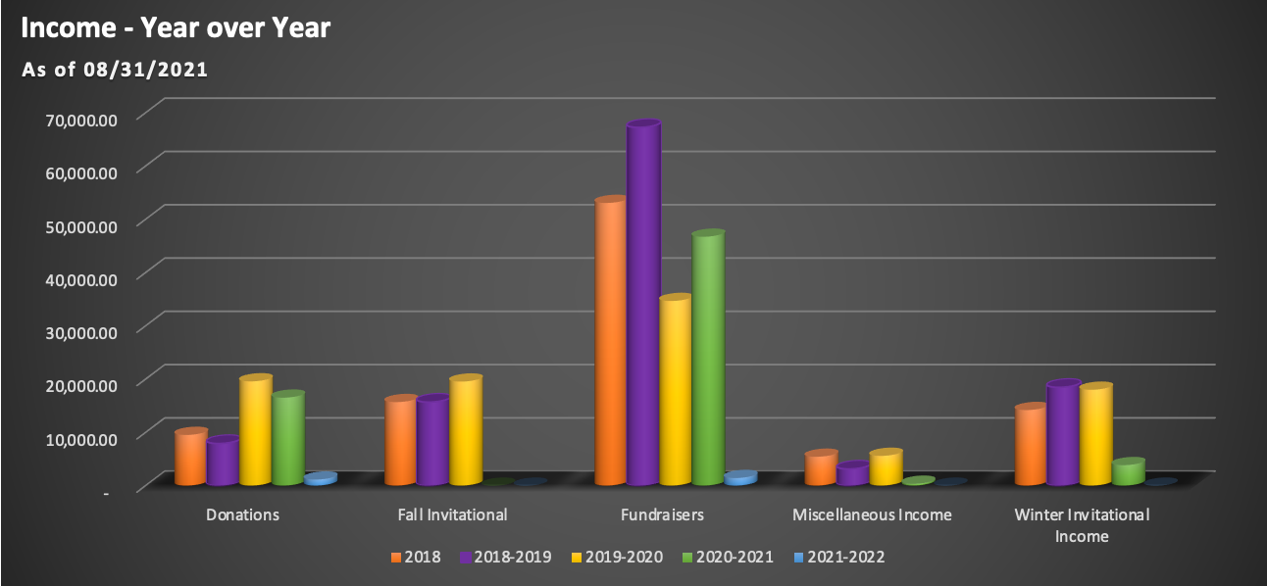

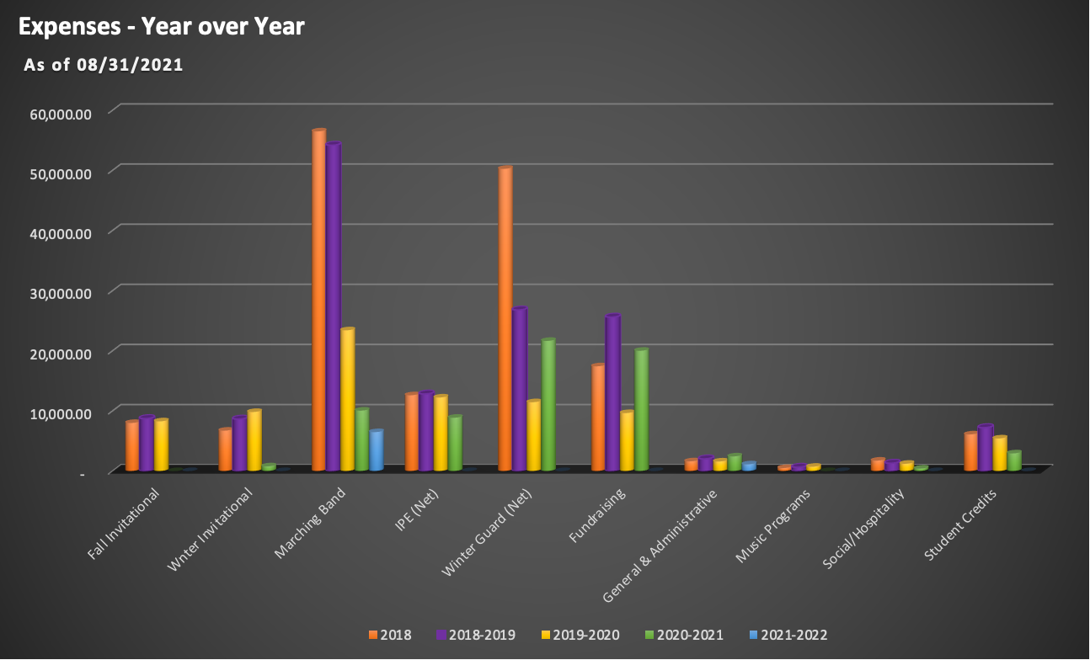
APPENDIX A
Treasurer Report
13Sept2021
Page 4/6

APPENDIX A
Treasurer Report
13Sept2021
Page 5/6

APPENDIX A
Treasurer Report
13Sept2021
Page 6/6

APPENDIX B
Foertmeyer & Sons Greenhouse Spring Flower Sale Presentation

Spring Flower Sale 2021 – Foertmeyer & Sons as potential vendor
Company Background:
- Foertmeyer & Sons has been in business for 30 years and has a service footprint in all OH, Northern KY and southern MI.
- Bellbrook Choir has used for Mumkins sale.
- They solely provide products for fundraisers.
- How they grow plants – Do not use pesticides. Grow at a cooler temperature (~50 degrees) which produces a hardier plant.
- For every plant, there is a ‘tip video’ available on their website. This will help users know what plants will work well for them and how to care for the plant.
  - Youtube.com/fortmeyerplanttips
- The catalog for spring contains approximately 35 items.
- Sales director assisting us – Drew Kesig
Pros | Cons
- Business solely supports fundraisers, so they are focused on the end user experience.  - Website (fundraiseIt.com) available to support orders  - Every student will be provided by Foertmeyer & Sons a ‘student store’ website. We will provide a roster for them.  - Website will support payments, so we would only collect for check/cash payments  - Fundraiser administrator has a real time view to see sales performance by student or overall.  - ‘Pull sheets’ can be printed from the software to know what sales each student had. This will assist on pick up / delivery day.  - Foertmeyer & Sons will deliver and sort the items on delivery day. Additionally, they will help setup the parking lot to facilitate a drive thru pick experience.  - Incentives are offered for the kids to sell  - For every 5 items the kids sell they earn an entry into a raffle. Some prizes are Air pods, PS5, Oculus  - There is a $0.10 per unit rebate that can be used by the school to facilitate sales competitions. Brass vs percussion competitions, etc. | - No gift card options are available because there are no retail locations.  - The spring 2020 flower sale sold 110 $25 gift cards  - Less profit per item.  - Average per product profit with Foertmeyer & Sons is $5.  - The spring 2020 flower sale had $8.50 profit per item with gift cards included or $9.03 without gift cards.  - If fewer than 700 units are sold, there is a $200 delivery charge  - The spring 2020 flower sale sold 729 plant units and 839 units with gift cards.  - ~40 units would need to be sold to obtain $200 profit (approximate break even point)

